December 13th, 2009
Hi
Not much to write about. The broadband technician came last Monday afternoon to fix the link again. Very irritating as modern life depends so much on the Internet and yet it is only about 10 years that people, in general, have been using it. Imagine going back to the days of having to write letters! You probably don’t know what that is like.

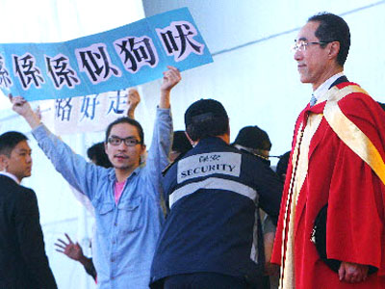
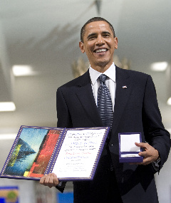
On Thursday, CUHK had its annual graduation ceremony (which I never attended not even once while there; it is not compulsory and if we all turned up there would not be enough space to seat us all). As is usual, a number of honorary doctorates were ‘awarded’. One who received such an award was Henry Tang, the Chief Secretary (second to the CE). A number of students disrupted the ceremony in protest, claiming that he did not deserve it because he has done nothing to help the poor or to bring about universal suffrage, both of which he is responsible for, and also that the university is ‘kow-towing’ to him as he may, heaven forbid, be the next Chief Executive. Many others, as well as these students, criticised the award of the degree. I sympathise with the protesters though not with the way they went about it. In general, I dislike the idea of awarding honorary degrees as universities can easily abuse it just to curry favour or be associated with certain people.
I watched Obama giving his acceptance speech for the Nobel Peace Prize the other night (or for you I guess it was early morning). Good speech, though because it was very long, I cannot recall that much of it.
The run yesterday was not as good as that of last week. It was 6 minutes slower than same route last season (which was quite a fast time). So the 6 minutes I gained last week I lost yesterday.
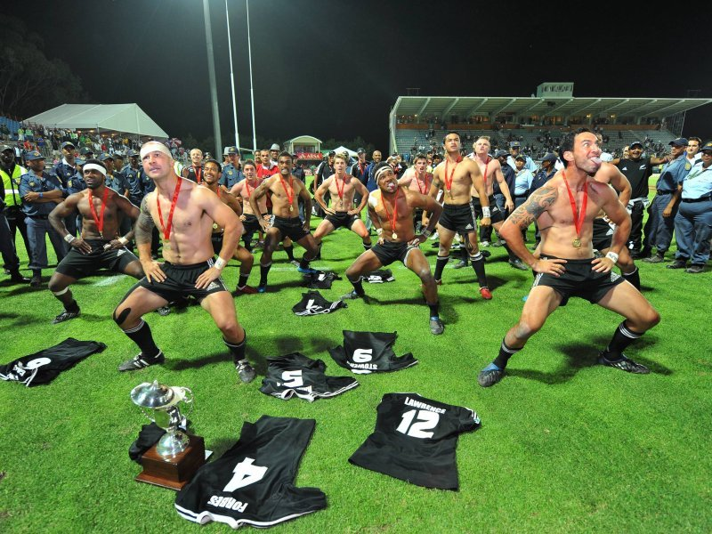
NZ won the second round of the IRB 7s, which was held in SA. So they have now won both the opening rounds. The East Asian Games ends today – I think. I have not been following it closely, just seeing the clips included during the news. HK has done very well actually, considering it is only a minnow in the world of sports. This was helped, as I mentioned last week, by being able to include sports in which it had a good chance. So it won medals in ‘artistic cycling’ ‘bicycle soccer’ and 10-pin bowling. HK also won all three golds in wind surfing. However, it helped that many of the best athletes in the region did not bother to come (as in the wind surfing). Also, some athletes just turned up one or two days before their events and then left once the event was over! I guess they think, correctly, that the games are not that important. Certainly, I have not seen any news on the games on non-HK TV stations and I guess that is the same for the US.
I saw on the TV news the heavy snowfalls in parts of the US. I guess you too were affected.
I have attached a file of pictures that may be your residences that I found on ‘Google maps’. Are they correct? Gavin’s may be wrong as Google did not seem to accurately locate ‘4 Concord Ave’ and gave pictures of other streets, e.g. 38 Trenton St.
That’s about it for now.
Cheers

